Development of a control system for the lean angle of a motorcycle using the gyroscopic effect of a rotating fly wheel

**James Davies**

Department of Physics

University of York

MPhys Project Review

Supervisor: Dr. Phil Lightfoot

jd1042@york.ac.uk

October 2017

1. **Introduction**
2. **Theory**

**2.1 Gyroscopic Theory**

If a wheel is spun, then it produces a given angular momentum, which is dependent on the mass and size of the wheel, and the angular velocity of which the wheel is spinning at.

To find the angular moment which is expressed as **L**, the moment of inertial for the wheel must be calculated first. It can be found using:

$I=\frac{1}{2}M_{w}R^{2}$ (1)

Where M­w is the mass of the wheel and R is the radius of the wheel. Therefore, I is constant for a particular wheel. Using the moment of inertia of the wheel the we can find the angular momentum for a given speed of rotation:

$L=Iω\hat{z}$ (2)

Where ω is the angular velocity, and ẑ is the unit vector of the plane perpendicular to that the wheel is rotating in (**CHECK THIS**).

This angular momentum must be conserved, which is what gives rise to gyroscopic precession. Looking at figure 1 below, there is a wheel that is spinning with an angular momentum **L** and is distance *x* from a pivot point. There is an external force from the wheel and rod mass acting down producing a rotation towards the ground.

Figure 1 - A simple gyroscope system from the side and above

View from above

View from side

**FINSIH THE DIAGRAM WITH LABELS**

The wheels rotation towards the ground produces a torque from the result of its mass and acceleration due to gravity, which using the right-hand rule we can determine the direction to be perpendicular to the plane of the page. The rotation of the wheel about the rod again produces a torque, in the direction of the rod (right-hand rule). In the case of figure one this is towards the pivot direction. The resulting torque produced from these motions is what causes the rotation known as precession, which is counter-clockwise in figure 1.The magnitude of the precession toque can be determined if we look at the angular velocity of the wheels rotation around the pivot and the rod:

$τ_{prec}= I_{f}ω_{rod}ω_{piviot}$ (3)

NEED TO LOOK INTO THE RESTORING FORCES WHICH

THEN NEED TO LOOK AT THE THEORY IN A FRAME, FOR CONTROL OF THE BIKE

**2.2 Motorcycle mechanics**

When a motorbike is travelling along at a relative speed the upright angle of the vehicle is considered stable, as it would require a large external force on the bike to knock it over. The stability is due to the rotating motion of the wheels producing a gyroscopic effect. The angular velocity of the wheel produces an angular momentum which must be conserved. To change the change the orientation of the bike requires a force to overcome the resulting precession torque from rotating wheels, as explained above.

This gyroscopic motion of the wheels also explains the requirement for leaning when cornering on a motorcycle.

The addition of spinning flywheels inside of a motorcycle almost seems counterintuitive initially as a rider would have to “fight” the precession torque of the flywheels to corner, thus reducing handling of the bike.

If we link these flywheels to the steering of the bike, to rotate the angle of lean from the gyroscopic forces produced in the flywheels, then the vehicle will feel lighter to the rider as. The force needed from the rider, as required in the normal handling of the bike, will “feel” reduced compared to the weight of the bike, as the majority of it will be produced from the rotating flywheels, but controlled by the rider’s handlebars and weight.

<HAVE A LOOK IF INCREASED ACCELERATION FROM RETURN TO COMPLETE UPRIGHT FASTER WOULD HAPPEN>

The lighter feel to the handling of the bike would not only be the only added benefit. A bike which internally controls the angle in which it is leaning with respect to the road is also safer, especially in worse road conditions.

<INSERT FIGURE HERE>

As can be seen in figure X above, when a normal motorcycle is cornering in poor road conditions the wheels loose traction and the bike “slips” causing the bike to completely fall on its side, likely injuring the rider in the same instance. In the case where the angle of lean can be controlled from the flywheels rotation inside of the bike, when the tires loose traction with the road surface the bike would appear to drift along the surface, whilst maintaining its rotational position. This will give the rider a greater chance of recovering from the slide without losing total control of the bike.

Both safety and handling performance would increase with the use of flywheels to exert internal torques on the bike, but would come with the disadvantage of a greater amount of weight on the bike. Even though this weight would not be felt by the rider, it would negatively affect the acceleration of the motorcycle.

**2.3 Electronic theory**

When constructing an electronic circuit to build the system to control and regulate the gyroscope, there is a need for a few key electronic devices when working with motors, servos and microcontrollers.

**2.3.1 MOSFETS**

A metal-oxide semiconductor field effect transistor or MOSFET is a transistor, n-channel of which being used in this project, which essentially acts of the valve of current to control external electronic devices like motors.

As shown in figure 3 (**Insert figure here**), they have three pins known as gate, drain and source. As their names suggests, the drain is the pin in which the current drains into, while the source leads to the ground. The gate is the control pin which is used to change the current flow between the drain and source pins via a control voltage. Logic level MOSFETS will be used in this project as they only require a 5V source to activate and deactivate the device, which can be provided from an Arduino microcontroller.

The MOSFET does not act as a switch but a variable resistor with an activation voltage. (**Go look at the ones being used and quote values**). This means that not only can the MOSFET be used to turn on something like a motor, but also how fast the motor is running from the gate input voltage.

Since MOSFETS are used in high current applications, it is also important to check the Power dissipated using:

$P_{dissapated}= R_{DS}I^{2}$ (4)

Where RDS is the resistance between the drain and source controlled by the gate and *I* is the current flowing through the MOSFET. To find the maximum power that a MOSFET can handle without using a heat sink we can use the equation:

$P_{dissapated }= \frac{T_{junction-max}-T_{ambient}}{R_{junction-ambient coeefficent}}$ (5)

The gate of the transistor has a couple of limitation of the control voltage to switch the transistor on and off. The signalling voltage should be kept below 15V to avoid damages. However, the drain and source voltages are a lot more flexible and dependent on the transistor, but can support much greater voltages.

**2.3.2 Voltage Regulators**

A voltage regulator is a device that takes a unregulated input voltage which can be challenging overtime and outputs a smooth output voltage, but with a few implications:

* Linear voltage regulators are not very efficient.
* They have a drop-out voltage.

To look at the efficiency of a voltage regulator we look at the power dissipated across it:

$$P_{dissapated}=(V_{in}-V_{out})I_{out}$$

To avoid inefficiencies and high device temperatures we avoid high input voltages, but making sure to avoid Vin fluctuating below the drop out-voltage.

The dropout voltage refers to the minimum input voltage that you have to pass to the regulator to guarantee a stable output. To provide this stable output the “head room” voltage will be dependent on the voltage regulator used but in case of (**Again look at one on bike**).

Most regulators will have the same naming convention, looking something like:

**78XX**

where the *'s will be some letters and the XX an indication of the Voltage it will supply. For example:

***LM7809AC*** is a 9V regulator.

**2.3.3 Resistors**

When working a microcontroller like an Arduino, care is needed not to over current the pin connectors, damaging them. One of the most common ways of protecting sensitive electronic components like these pins is to add a resistor. Ohms law can be used to find the resistor needed to protect a pin from over current.

Another feature of working with logic circuits with Arduinos is pull up/down resistors. A pull-down resistor is connected to the ground in the circuit and pull down any voltage so that a device like an Arduino pin rests at zero when no other devices are connected or a high impedance component acts like a disconnection. A pull-up resistor does a similar role but pulls the resistance up to the expected logic level in the same case of disconnected like circuit.

**2.3.4 Breadboards**

Breadboards are a device used to allow circuits to be created without the need to solder the components together. Figure 4 (**Put a figure here**) shows a picture of a bread board, highlighting the power rails/buses, and electrical connections. The break in the centre of the bears is designed so microchips can be placed into the board with full connectivity. All the components are held in place with small metal clips, which also act as the electrical connection.

**2.4 Microcontroller**

Microcontrollers are small electronic devices, also known as logic chips. These chips are processors housed in a microchip, which can be used in electronic circuits. For this project we are using microcontrollers that are already integrated into an electronic circuit to allow the quick and easy use in other electronic circuits. The two that boards in question are the Arduino Uno SMD (**Check**), which uses an 8-bit chip called ATmega328, and the Genuino 101, which uses a more powerful 32bit chip called the Intel Curie. Both boards are of very similar design, the Genuino pictured below in figure **IVE LOST COUNT.**

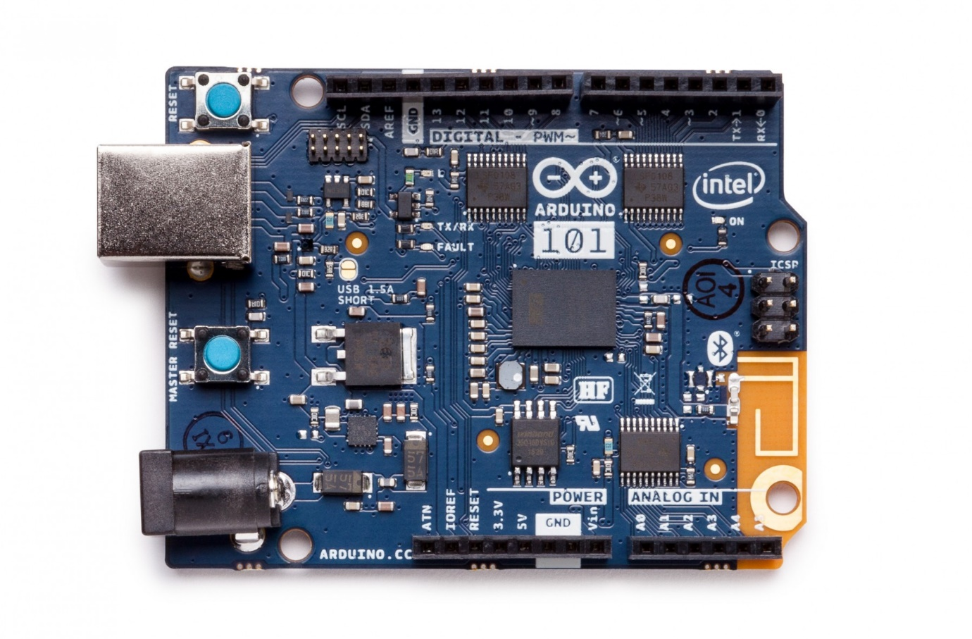

Figure 2 - Genuino Board [Bob]

Both the Genuino and the Arduino have the same form factor but with a few differing functionalities. The important similarities between these boards are the control pins which can provide up to 5V power supple and have PWM pins, represented by the (~) symbol.

Using PWM pins on an Arduino board allows the changing of pulse times of the output voltage, allowing for a stable and changeable average voltage to be produced. This is incredibly useful, for example it can be used in conjunction with the gate on a MOSEFT can be used to control the current output for an external device, like a motor and therefore it’s speed.

**2.5 PID Theory**

Proportional-Integral-Derivative (PID) control

1. **Methodology**

**3.1 Test system construction**

**3.2 Code development**

**3.3 Project progression targets**

1. **Conclusion**
2. **References**

[bob] - https://store-cdn.arduino.cc/usa/catalog/product/cache/1/image/1800x/ea1ef423b933d797cfca49bc5855eef6/a/b/abx00005_front.jpg